***Name : HIMANSHU DIXIT***

***Enrollment Number: B64178***

***Batch: B10***

***Experiment No : 6***

***(PLANK’S CONSTANT)***

***Aim:***

*To determine the plank’s constant.*

***Formula Used:***

|  |
| --- |
| h= (e/c)*X*V |

*Where,*

*h is the plank’s constant*

*e is charge of electron , c is the speed of light and e/c=5.33*10^-28Cs/m*

*X is the wavelength of light.*

*V is the knee voltage.*

***Obesevation table:***

|  |  |  |  |  |
| --- | --- | --- | --- | --- |
| ***Sr. No.*** | ***Colour of led*** | ***Wavelength***  ***(nm)*** | ***Knee volatage(V)*** | ***h=eXV/c***  ***(kgm^2s^-1)*** |
| *1.* | *Red* | *750* | *1.903* | *6.566*10^-34* |
| *2.* | *Green* | *510* | *2.430* | *6.566*10^-34* |
| *3.* | *Yellow* | *570* | *2.178* | *6.566*10^-34* |

***Calculation :***

1. *For red :-*

*h=eXV/c=5.33*10^-28 * 750*10^-9 *1.903 = 6.566*10^-34.*

1. *For green:-*

*h=eXV/c=5.33*10^-28 * 510*10^-9 *2.430 = 6.566*10^-34.*

1. *For yellow :-*

*h=eXV/c=5.33*10^-28 * 570*10^-9 *2.178 = 6.566*10^-34.*

***Graph:***

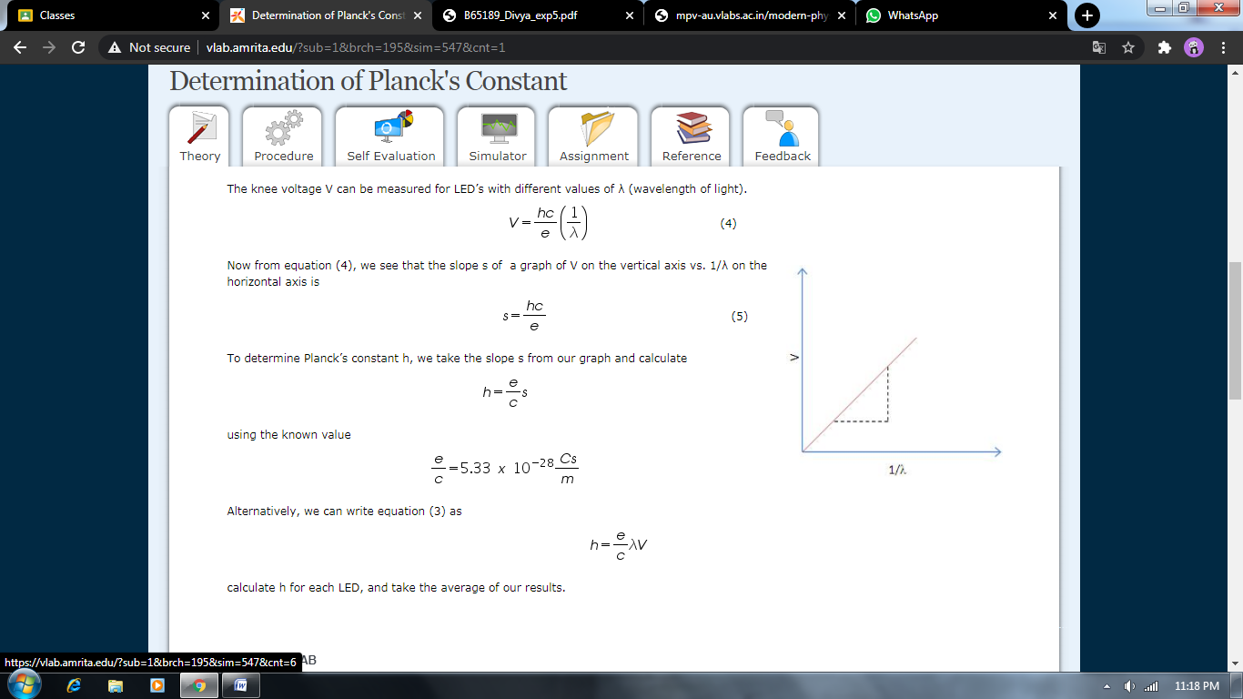

***Result:***

*This experiment shows that plank’s constant is constant.*

*Plank’s constant is*  ***6.566*10^-34 .***

